- The chief financial officer believes that we should maintain the present course, and ------- his deputy.
  - as to
  - whereas
  - as does
  - as long as
- ___you have familiarized yourself with the basic commands, we can begin to learn some of this program's more creative features.
  - Already
  - Before
  - Once
  - Earlier
- The director ------- has often been seen to take his lunch in the staff canteen along with the other workers.
  - him
  - his
  - himself
  - he
- The Department of the Environment supports the replacement of introduced plants with ------- plants that require much less watering.
  - native
  - nativity
  - natively
  - nativeness
- Several exciting new pieces of equipment ------- in our gymnasium, and we invite you to come and try them out at no cost during the next week.
  - install
  - installed
  - have install
  - have been installed
- A small group of contestants has been selected following a nationwide search ------ over the last six months.
  - alerted
  - engaged
  - protected
  - conducted
- Naturally, our company utilizes the production process ------- guarantees the most satisfactory results.
(A) that
(B) who
(C) what
(D) how
- According to the sign posted in front of the main office, the repair center is now........... new management.
(A) over
(B) around
(C) between
(D) under
- Health inspections are conducted ........... at restaurants throughout the province for the purpose of maintaining high standards of hygiene.
(A) extremely
(B) marginally
(C) overly
(D) routinely
- Numerous speakers came forward to express their gratitude ------- the retiring secretary 's unfailing courtesy and efficiency.
(A) for
(B) at
(C) to
(D) with
- ------- you are no doubt aware, the new security system requires the installation of a backup power source in case an emergency situation arises.
(A) As
(B) For
(C) With
(D) So
- ABC Shoe Store asked------to make their final selections and bring them to cashiers' stations within 30 minutes.
A) shopper
B) shopping
(C) to shop
D) Shoppers
- Rexington Engineering has recently set up an entire new research ------- because of the increasing interest in robotic technology.
(A) separation
(B) partition
(C) segmentation
(D) division
- Electron Recycling has developed a profitable business by recycling metals retrieved from ------- electronic components.
(A) discarded
(B) extended
(C) unoccupied
(D) suppressed
- Consultation with the appropriate experts is essential if we are to arrive at an ------ decision.
(A) informed
(B) obtained
(C) enlightened
(D) acquainted
- -----
- Once you have paid the appropriate student fees, you will be able to ------- the medical, recreational, and other facilities.
(A) access
(B) accessed
(C) accessory
(D) accessible
- Company strategists -------- predicted that conditions in the Middle East would eventually stabilize and result in expanded sales.
(A) wrong
(B) wronged
(C) wrongly
(D) wrongness
- ---
- The unexpected surge in the prices of steel and other minerals will result in a dramatic increase in tax ------- this year.
(A) rates
(B) charges
(C) expenses
(D) revenues
- The secretary filling in at the reception desk has been performing so well that management is considering offering her a ........... position.
(A) durable
(B) periodic
(C) binding
(D) permanent
- ------- leaving school, she has worked in a variety of positions but has not yet found one which suits her talents or interests.
(A) Despite
(B) Since
(C) In spite of
(D) If
- This is an excellent time to consider changing jobs because of the large number of positions
------- available in the mining sector.
(A) commonly
(B) currently
(C) actively
(D) approvingly
- ........... wanting to apply for maternity leave should let their immediate supervisor know about their plans at least one month in advance.
(A) Them
(B) That
(C) One
(D) Those
- An independent investigator ------- a report on the company's financial operations which, for some unknown reason,was never released.
(A) contracted
(B) confirmed
(C) compiled
(D) converted
- As you would expect at one of the world's most reputable hotels, the -------- is prompt, . efficient, and discreet.
(A)exertion
(B) decision
(C) challenge
(D) service
- After a highly profitable first six months, the restaurant's profits for the second half of the year were a great -------.
(A) disappoints
(B) disappointed
(C) disappointing
(D) disappointment
- All drivers are required to maintain ------ logbooks accurately and to hand them in to the central office before leaving on Friday night.
(A) its
(B) his
(C) our
(D) their
- It is true that the number of traffic accidents involving cyclists has increased ------- over the last 10 years.
(A) meagerly
(B) fundamentally
(C) significantly
(D) adequately
- The Department of Social Welfare's report this year indicated that it is focusing ------- on the homeless and long-term unemployed.
(A) distinctly
(B) individually
(C) exceptionally
(D) particularly
- The upcoming convention invites ------- from anyone working or having research interests in the field.
(A) contributions
(B) solutions
(C) additions
(D) subscription
- ------- the recent sales campaign was not as successful as we had expected, our new range of goods has been well reviewed by consumer groups.
(A) Instead of
(B) Notwithstanding
(C) Although
(D) Whereas
- Although he did not perform -------- well as a student, he went on to become one of the most respected scholars in his field.
(A) especially
(B) sufficiently
(C) desperately
(D) excellently
- The new head of marketing is already making his mark on the company even though he only
------- 6 weeks ago.
(A) carried
(B) elapsed
(C) deliberated
(D) arrived
- The giant pharmaceutical company insists that its new drug is ------- safe as long as it used under the supervision of a doctor.
(A) perfect
(B) perfection
(C) perfectly
(D) perfecting
- While we still take telephone calls, other .............. of correspondence are encouraged to avoid tying up telephone lines unnecessarily.
A. profiles
B. views
C. outlines
D. forms
- As of October 1, Carla Fishermen will----- the company as its interface in all dealings with the local government.
- accommodate
- perform
- attend
- represent
- ............in computer technology are allowing users to reach into any part of the world by just clicking a mouse.
A. advance
B. advancing
C. advancement
D. advances
- Ms. Julie Kennedy and her innovative marketing team have gained renown for creating__products for struggling companies.
A. promote
B. promotes
C. promotion
D. promotional
- The Technical Department is currently formulating written guidelines ------- the use of our micro-publishing facilities.
(A) in
(B) for
(C) at
(D) with
- ---
- ---
- --
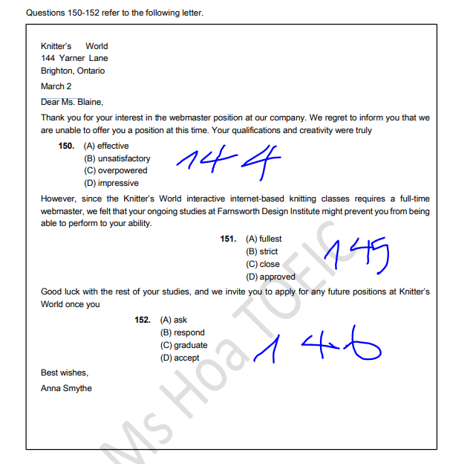
- D) impressive
- A. fullest
- C. graduate
_________________________________________________________________________________________
Dianne Olsen
152 Citizen Road
Manly, Sydney
Dear Ms. Olsen:
I'm sorry to inform you that we are ____ you DF Banking credit card account.
- A. canceling
B. suspending
C. opening
D. renewing
Your current balance is -$2,346.50 , and we received only $1,100 by way of payment from you last month. Your account will not be reactivated until you completely clear this debt. In order to ensure we collect debts from delinquent account holders, we offer customers in your situation a number of repayment ____ . Please contact us by email at inquiries@dfbanking.com or
- A. opts
B. options
C. optional
D. optionally

by phone at 0100-772-355 for more details. If you do not get in ______ with us, we will continue to
- A. conduct
B. touch
C. connection
D. link
charge your account at 12% interest. Moreover, should you fail to begin repaying your debt in a suitably swift manner, we will be forced to take control of your account.
Yours,
Fred Grover
Manager-Accounts Payable
DF Banking
- ----
- –
- ---
- ===
- ===

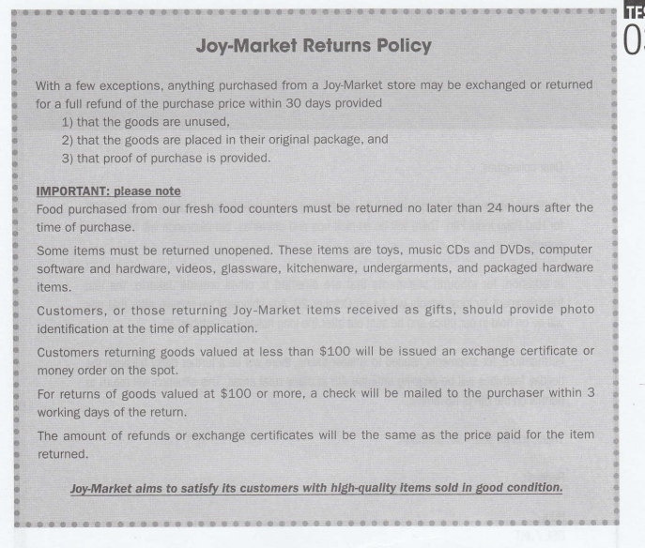
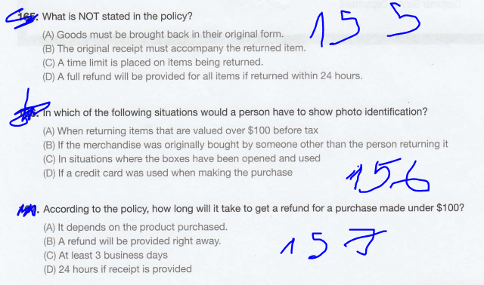

- D). A full refund will be provided for all items if returned within 24 hours.
- B) If the merchandise was originally bought by someone other than the person returning it
- B) A refund will be provided right away.
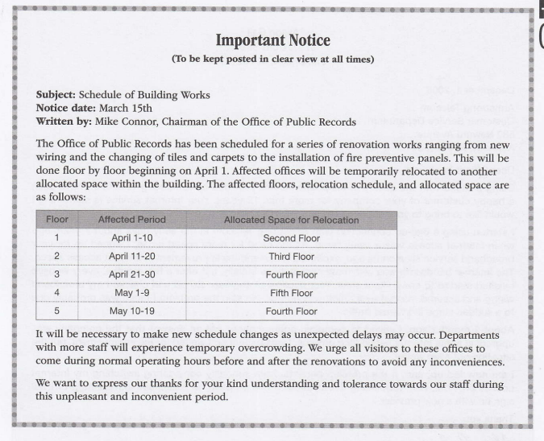

- What is the purpose of the announcement?
(A) To restrict unnecessary stafi members from visiting the work area
(B) To provide a timetable for some otfice renovation work
(C) To thank employees for their support in the work
(D) To prepare for an unexpected shipment delay
- Where will employees on the ground floor likely be on March 15?
(A) The first floor
(B) The second floor
(C) The third floor
(D) The fourth floor
- The word "urge" in paragraph 2, line 2 is closest in meaning to
(A) influence
(B) encourage
(C) support
(D) command
- During which period will the employees on the fourth floor not be affected?
(A) April 1 1-20
(B) April 21-30
(C) May 1-9
(D) May 10-19

(158. B) To provide a timetable for some office renovation work .
159. A) The first floor
160. B) encourage
161. A) April 11-20)

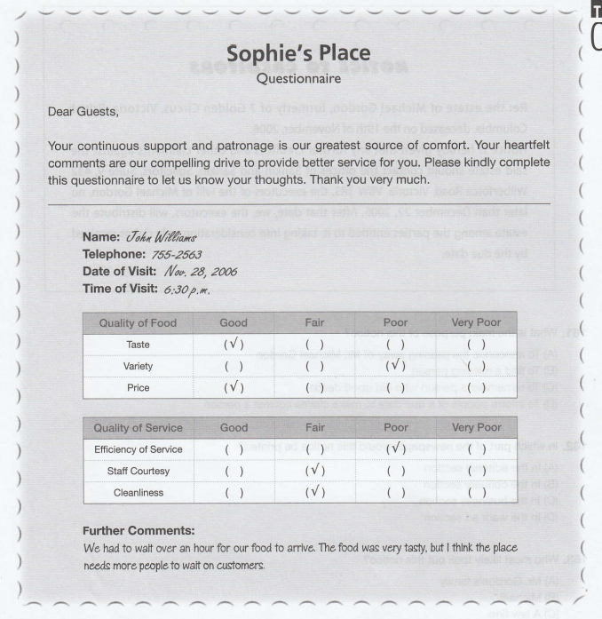
- Which of the following is NOT true about the results of the questionnaire?
(A) Mr. Williams felt that the restaurant was understaffed.
(B).Mr. Williams liked the food he had today.
(C) Mr. Williams felt thai the price was very unreasonable.
(D) Mr. Williams thought the menu selection needs were limited.
- What can be implied about Mr. Wlliams?
(A) He had dinner at the restaurant.
(B) He came with several guests.
(C) He is a regular customer.
(D) He is a very picky person"

(162. C Mr. Williams felt thai the price was very unreasonable.
163. A. He had dinner at the restaurant.)
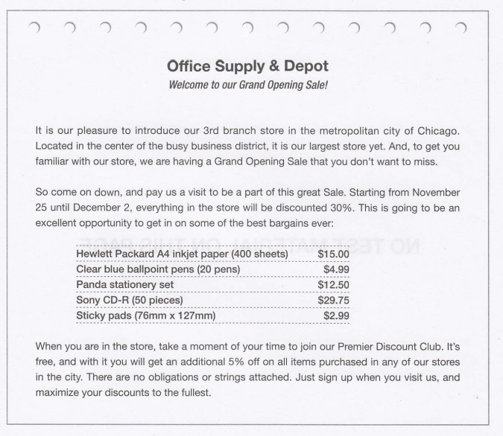
- What is suggested in the advertisement?
A) The store will be celebrating its third year of business.
(B) The price of items in the store will be slashed roughly by one third.
(C) The sale period will last for two months.
(D) The discounts will only be available to premier members.
- How can a customer receive the largest discount?
(A) By coming in early to the store
(B) By purchasing two or more items
(C) By signing up for a special members

164. B. The price of items in the store will be slashed roughly by one third.
165. C. By signing up for a special membership card
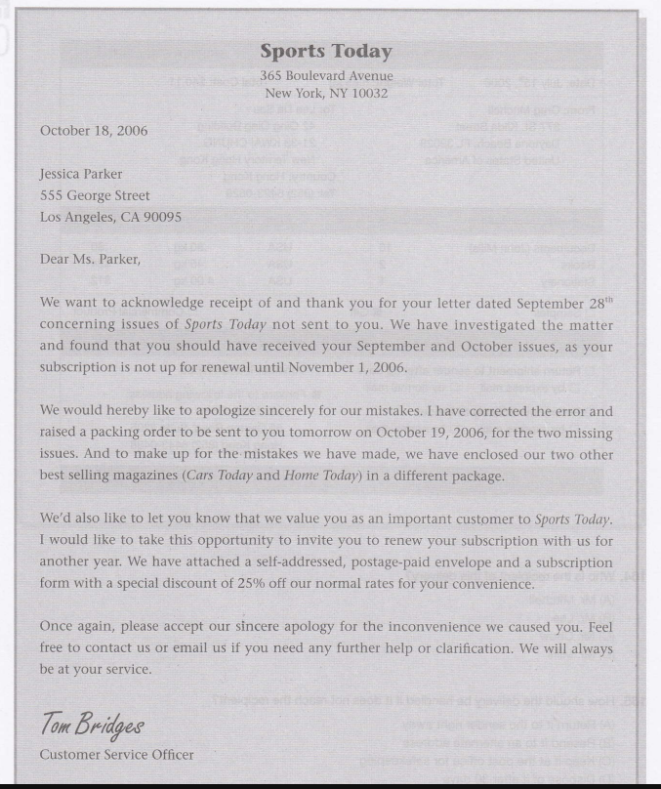
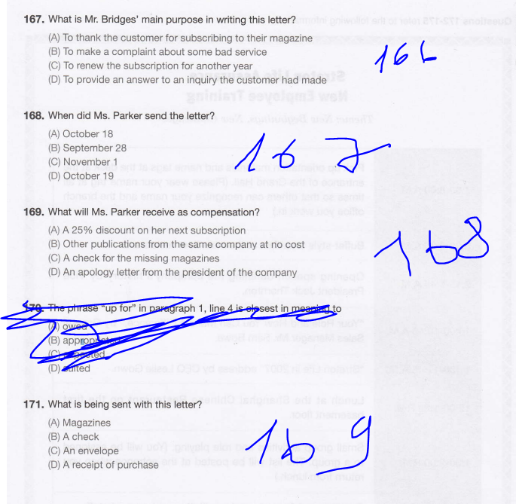

- D. To provide an answer to an inquiry the customer had made
- B September 28
- B. Other publications from the same company at no cost
- C. An envelope

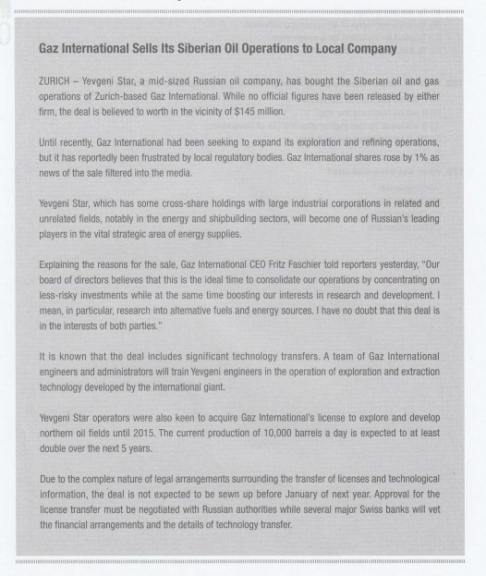

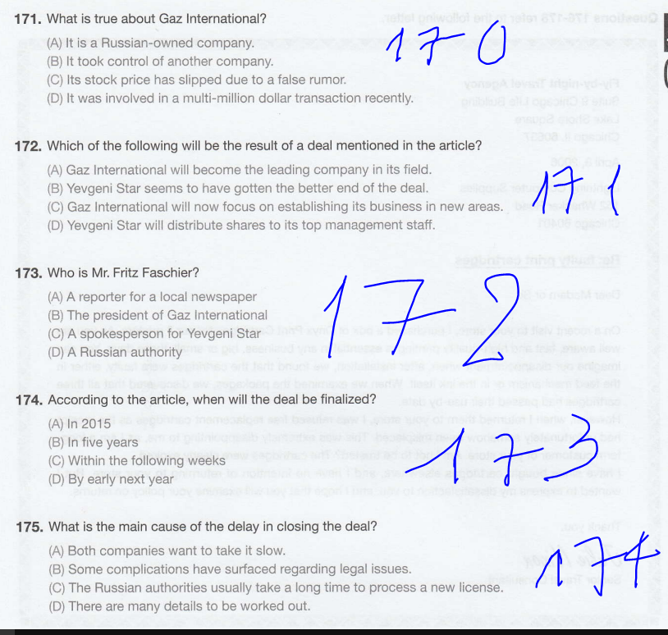

- D. It was involved in a multi-million dollar transaction recently.
- C) Gaz International will now focus on establishing its business in new areas.
- B) The president of Caz International
- D) By early next year
- D) There are many details to be worked out.
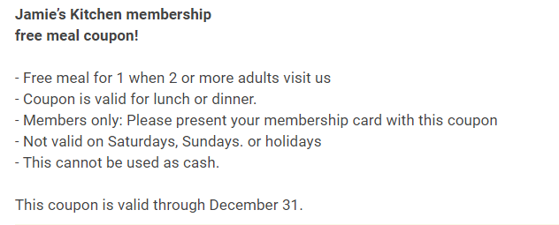
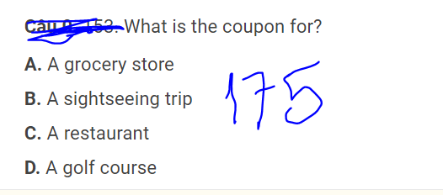
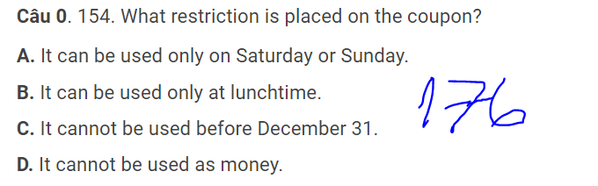

- C. A restaurant
- D It cannot be used as money.
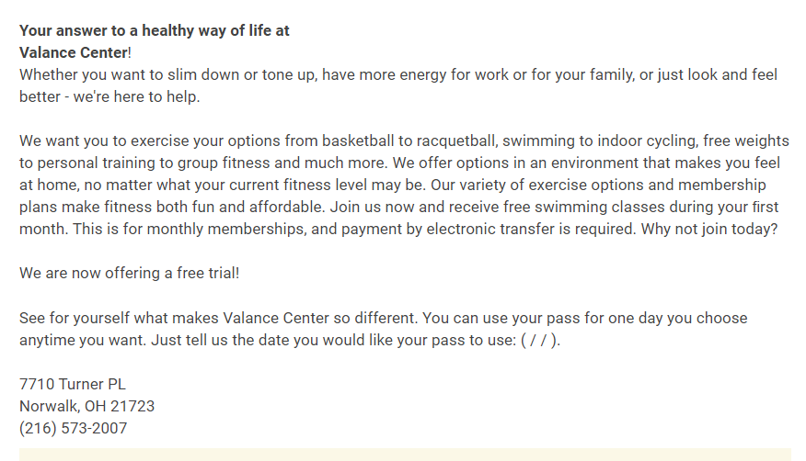
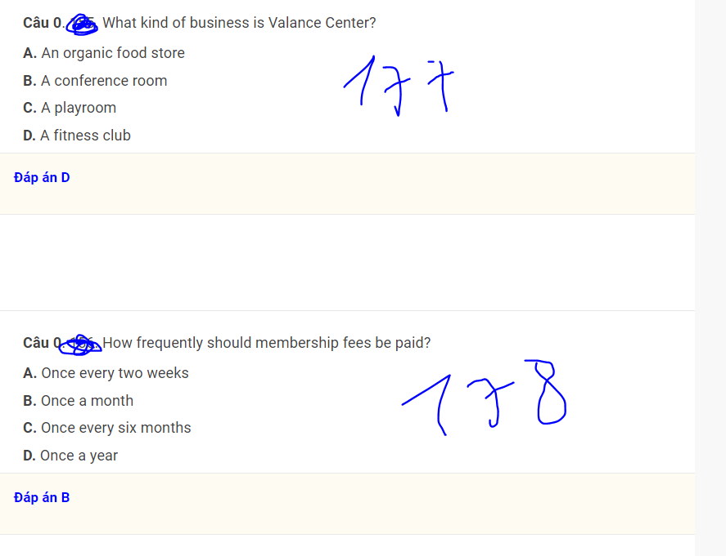
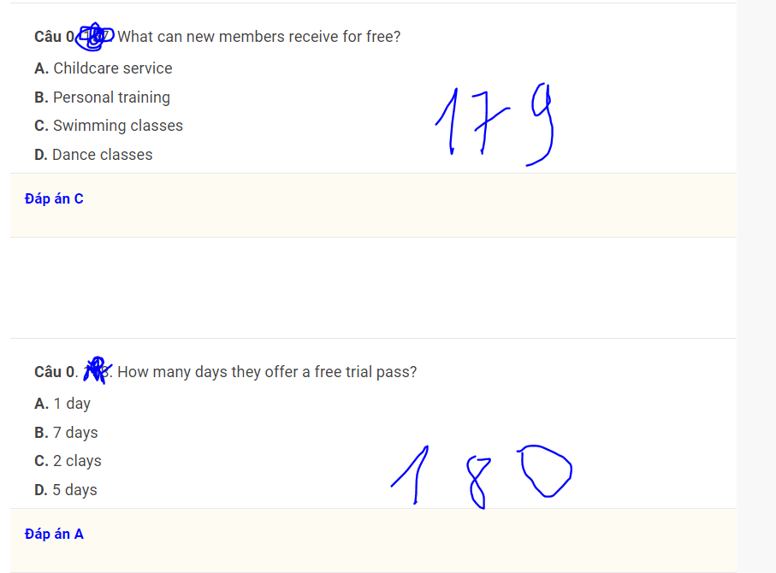

- D. A fitness club
- B. Once a month
- c. swimming classes
- A) 1 day
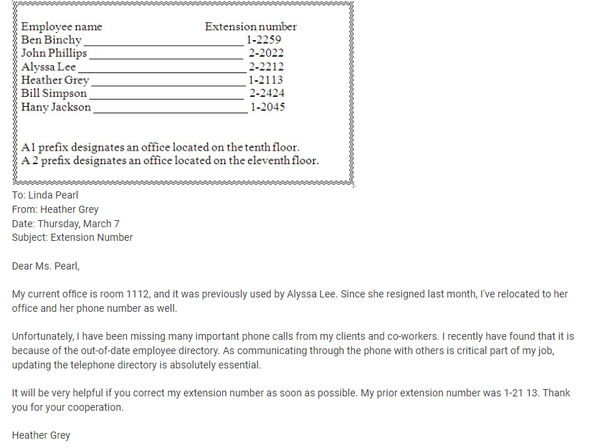
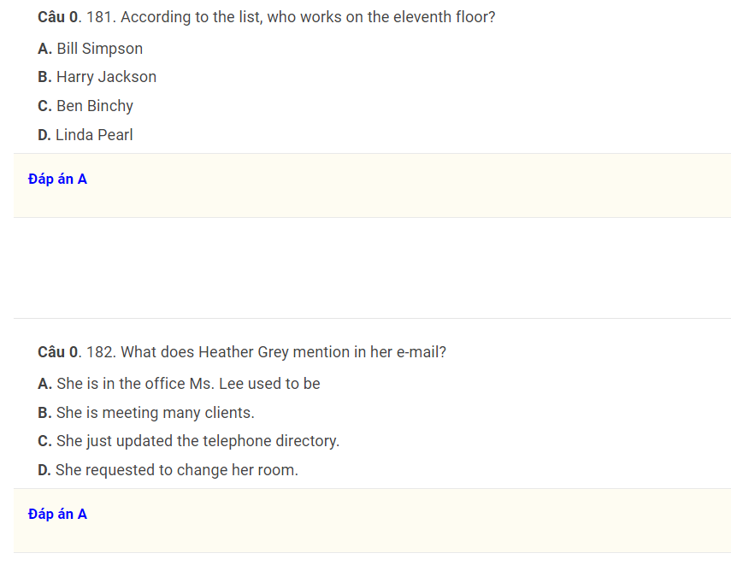
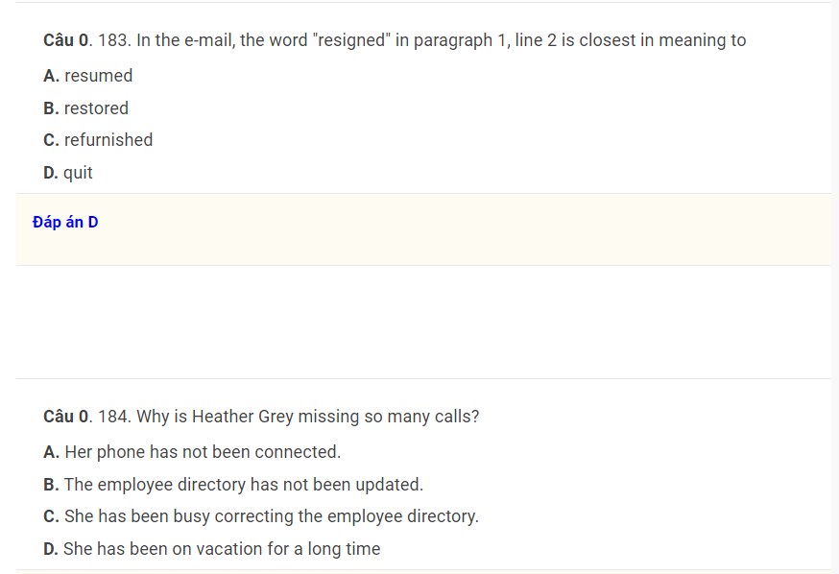
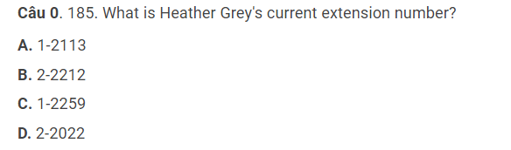
- A. Bill Simpson
- A. She is in the office Ms. Lee used to be.
- D. quit
- B. The employee directory has not been update
- B.2-2212
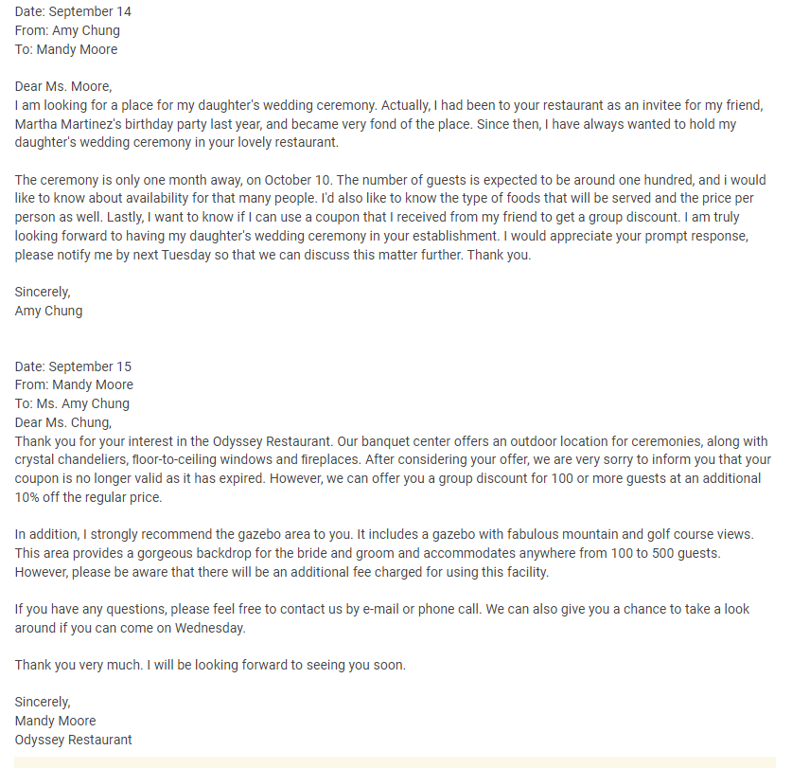
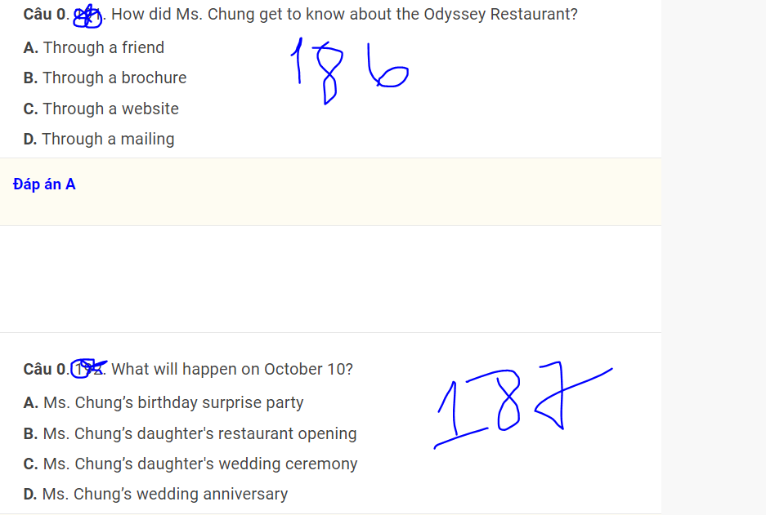
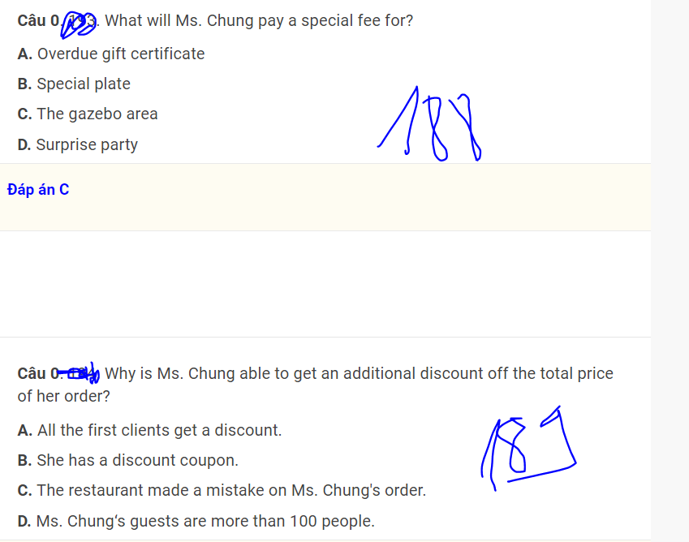
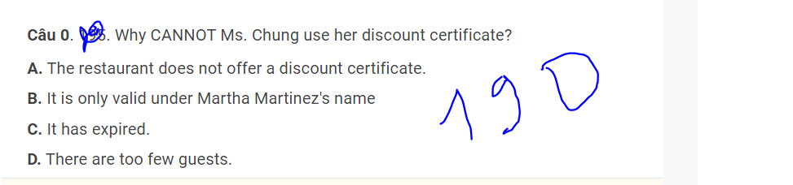

- A. Through a friend
- C. Ms. Chung's daughter's wedding ceremony
- C. The gazebo area
- D. Ms. Chung's guests are more than 100 people.
- C. It has expired.
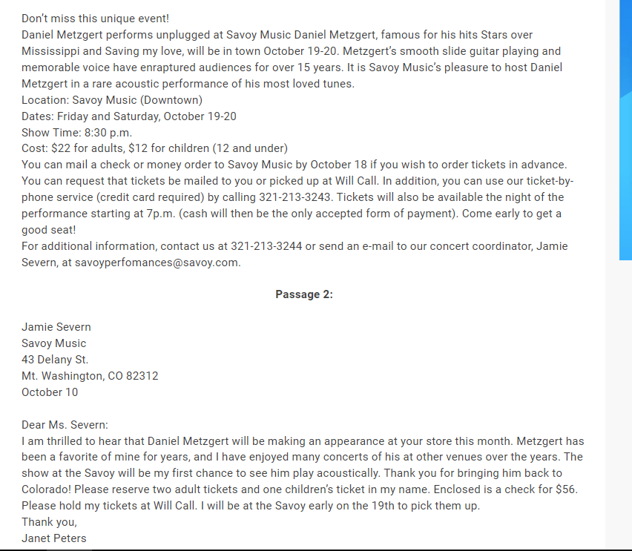
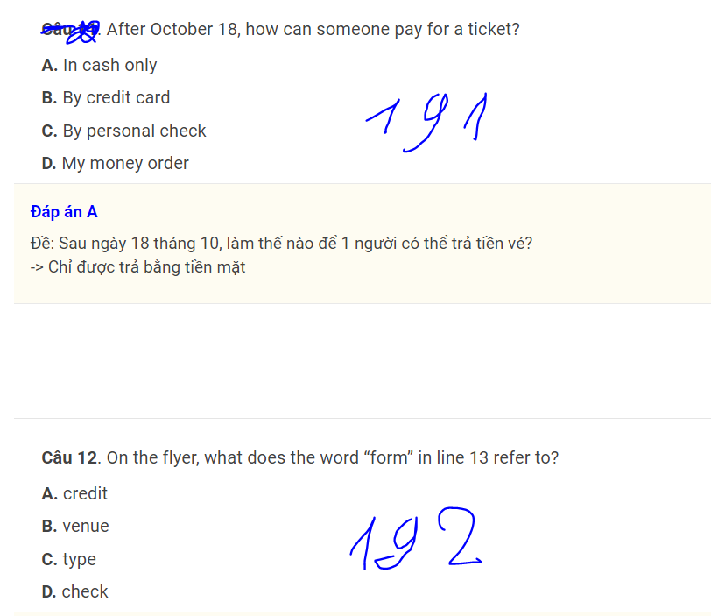
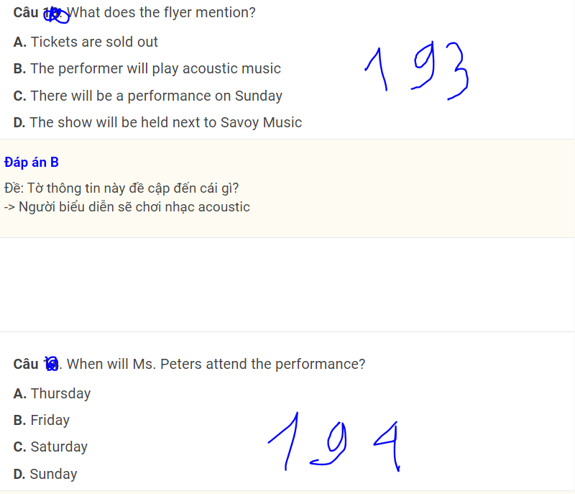
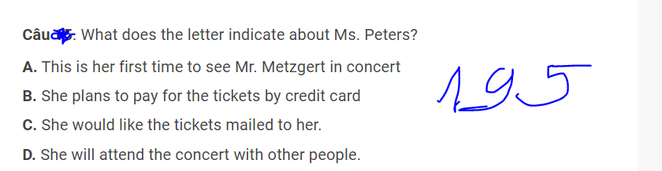

- A. In cash only
- C. Type
- The performer will play acoustic music
- Friday
- She will attend the concert with other people.

101. C) as does  102. C) Once  103. (C) himself  104. A) native  105. D) have been installed  106. D) conducted  107. C) what  108. D) under  109. D) routinely  110. A) for  111. A) As  112. D) shoppers  113. D) division  114. A) discarded  115. A) Informed  116. Tbd  117. A) access  118. C) wrongly  119. Tbd  120. (D) revenues  121. • D. permanent  122. (B) Since  123. B) currently  24. D) Those  125. C) compiled  126. D) service  127. (D) disappointment  128. D) their  129. (C) significantly  130. D) particularly  131. A) contributions  132. C) Although  133. (B) sufficiently  134. D) arrived  135. C) perfectly  136. D. forms  137. (C)attend  138. D. advances  139. D. promotional  140. A) in  141. G 142. H 143. H  144. D) impressive  145. A. fullest  146. C. graduate  147. B. suspending  148. B. options | 149. B. touch  150. G 151. G 152. G 153. G 154. G  155. D). A full refund will be provided for all items if returned within 24 hours.  156. B) If the merchandise was originally bought by someone other than the person returning it  157. B) A refund will be provided right away.  158. B) To provide a timetable for some office renovation work .  159. A) The first floor  160. B) encourage  161. A) April 11-20  162. C  163. A. He had dinner at the restaurant.  164. B. The price of items in the store will be slashed roughly by one third.  165. C. By signing up for a special membership card  166. D. To provide an answer to an inquiry the customer had made  167. B September 28  168. B. Other publications from the same company at no cost  169. C. An envelope  170. D. It was involved in a multi-million dollar transaction recently.  171. C) Gaz International will now focus on establishing its business in new areas.  172. B) The president of Caz International  173. D) By early next year  174. D) There are many details to be worked out.  175. C. A restaurant  176. It cannot be used as money.  177. D. A fitness club  178. B. Once a month  179. c. swimming classes  180. A) 1 day  181. A. Bill Simpson  182. A. She is in the office Ms. Lee used to be.  183. D. quit  184. B. The employee directory has not been update  185. B.2-2212  186. A. Through a friend  187. C. Ms. Chung's daughter's wedding ceremony  188. C. The gazebo area  189. D. Ms. Chung's guests are more than 100 people.  190. C. It has expired.  191. A. In cash only  192. C. Type  193. The performer will play acoustic music  194. Friday  195. She will attend the concert with other people.

